**FINAL REPORT**

**EX VIVO** PRECISION-CUT LUNG SLICES (PCLS) FOR PRO-INFLAMMATORY PATHWAYS

**Laboratory Study Number:** 20A167-A168.063001

**Study Initiation Date:** 26 January 2021

**Study Completion Date:** 16 July 2021

**Authors:** Holger Behrsing, Ph.D. Lindsey Ukishima, B.S.

**Sponsor** Brigham Women's Hospital Pulmonary and Critical Care Medicine 60 Fenwood Rd Hale BTM 3016-I Boston, MA 02115

**Performing Laboratory:** Institute for In Vitro Sciences, Inc. 30 W. Watkins Mill Road, Suite 100 Gaithersburg, MD 20878

**Laboratory Project Number:** 11339

Table of Contents

Methods: 4

Results: 4

Initial Exploratory Analysis: 4

Secondary exploratory analysis: 11

# **Methods:**

The Channing Division of Network Medicine Bioinformatics group received a data release from Bayer. The release included two sequencing runs with samples from the PCLS project, as well as another set of unrelated data. To avoid the possibility of sample swaps between the two unrelated sets of data, all of the data was aligned, quantified, and the samples were plotted in principal component space.

### Preprocessing:

The samples were prepared on two plates, numbered 668 and 669. The files were released using ids with the following format SK-<plate>-<id>: e.g. “SK-4ED3_A1”. The files were renamed by changing each character in the ids to ASCI and prepending “S-”, thus creating a synthetic sample id with the format “S-NNNNNN”. The files were renamed and merged. The merge process was done using the Channing Transfer Quality Control Workflow. [1]

Experimental treatment files were released by the functional lab in two stages. In the first stage, the data was annotated in terms of the treatments of the PCLS data. In the second stage, the freeze thaw data was also annotated. These were merged and annotated along with the synthetic S-ids to provide an input to the pipeline. The experimental treatment merging code was done and *redone using an R script [S14, *S13].

The Channing Alignment Workflow [S2] was run on the merged, renamed fastq files to create binary alignment mapping files where the reads are annotated with the best fitting chromosome-position in the GRCh38 reference [R1]. Summary statistics of the read quality were generated with fastqc [S4]. The reads were trimmed using skewer [S5]. The reads were aligned using STAR [S6]. The STAR index was generated using the gtf [R2]. The quality of the alignment was summarized with RNASeQC [S7]. The quality of the mapping process was examined using a custom shiny application to display the quality metrics. These quality metrics were used to remove several samples.

The Channing Quantification Workflow [S3] was applied to the BAM files generated by the alignment workflow to create raw and normalized count matrices as well as do differential expression analyses for various subsets, contrasts, and adjustments. The results were displayed in a custom shiny application that shows differential expression p-values along with quality control plots, as well as PCA plots.

An R script wrapper for the Rsubreads [S9] featurecount function was used to quantify the reads incident upon the gene and exon count features for the [R2] annotation of the GRCh38 reference. The resulting files were merged into count matrices and PCA plots were generated using DESeq2 [S11].

# **Results:**

### Initial Exploratory Analysis:

Our primary analyses was differential expression using DESeq2, pairwise between each substance, concentration, time point, and type of sample (either fresh or cryopreserved), versus the vehicle control at that same timepoint. To examine differential effects due to time, we also performed a longitudinal analysis for vehicle controls across all time points using F-test in limma and likelihood ratio test in DESeq2. To examine the effect of cryopreservation, we performed pairwise comparison of cryopreservation and vehicle controls at each time point and at all time points (with covariate for time). We also used Gene Set Enrichment analysis (using gsea and sigora).

We examined sample clustering by plotting principal components using variance stabilizing transformation. We examined the top principal components for separation of samples on the basis of exposure times, concentration, test substances and cryopreserved vs fresh samples. As we were using low-depth data, first we examined the effect of different thresholds for dropping lowly expressed genes. We compared various zero and low count thresholds with respect to the number of genes dropped, and then subsequently overlap on differential expression results and top genes to determine any of the thresholds had low base means.

As secondary analyses, we also tried alternative models. We examined the effect of adjusting for the effect of cryo, and Surrogate Variable Analysis to adjust for effects of other unmeasured technical covariates, using limma. To compare results, we examined clustering in principal component plots and overlap in differentially expressed genes. For these sensitivity analyses we focused on LPS fresh samples at 6 hours (0.1.ng, 1ng and adjusting for concentration). We checked for overlap between pairwise comparisons for fresh and cryo samples between enriched pathways, significant DE genes and used Pearson correlation coefficient to see the correlation between their log fold change. We tested for overlap in differentially expressed genes between pairwise comparisons for same substance and concentration/ time and across different test substances using Venn diagrams and UpSet plots. We also compared results from Limma and DESeq2 analysis for overlap on significant genes and log fold change correlation. We also observed the best time point in terms of DE genes, eigencor plots, looked up and plotted counts of expected LPS responsive genes across time, and saw trade off between DE and LPS responsive genes. Gene Set Enrichment Analysis was performed for unadjusted fresh samples pairwise comparisons, longitudinal analysis and cryo effects in vehicle controls.

We applied variance stabilizing transformation (VST) and inspected principal component plots. In all samples, we observed a clear separation between cryo and fresh samples for PC1 and PC2 (Fig. a). We then adjusted for cryo, effects, and replotted PCs. We observed clustering on time points. (Fig b.). We also plotted PCs within fresh samples alone, and identified a separation of LPS from TGFB and control (Fig c).

To determine the appropriate cutoff for zero counts, we applied several thresholds, and noted similar results in the top differentially expressed genes, with high correlation between log fold change. After comparing the different cutoffs, we decided to filter out genes with zero counts in 60% or more samples, anticipating that unstimulated or stimulated cells could have undetectable gene expression in our low depth experiment. In our secondary analysis, we attempted to use SVA adjustment. In contrast to the unadjusted counts, PC plots after SVA adjustment did not show a clear separation for test substances and exposure times. SVA analysis gave us fewer differentially expressed genes. We also compared  DESeq2 and limma results and found a high correlation between logfc and overlap between differentially expressed genes was observed. We decided to go ahead with DESeq2 due to the relatively smaller number of samples.

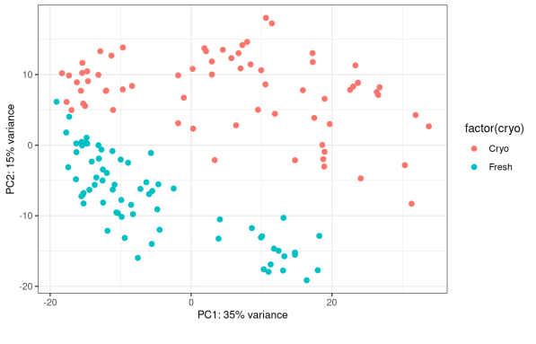

Fig a. Principal component plot for all unadjusted samples cryo vs fresh

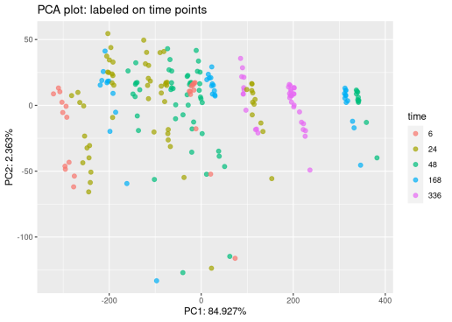

Fig b. Principal component plot after cryo adjustment labeled on exposure times

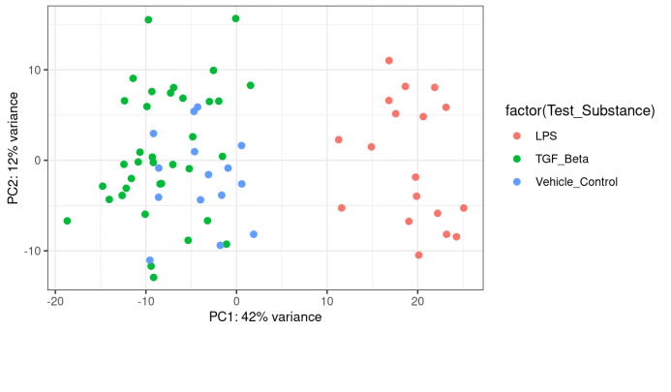

Fig c. Principal component plot for unadjusted fresh samples labeled on test substance

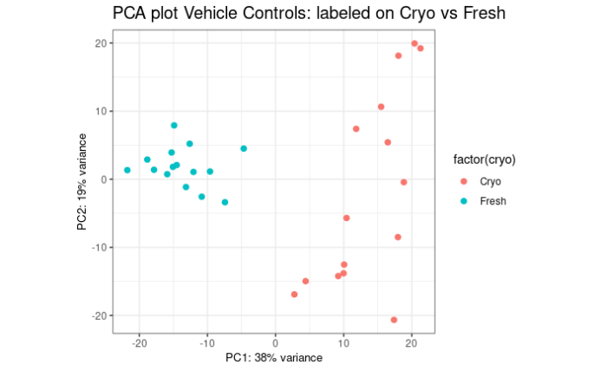

Figure 1B. Plot of principal components for Vehicle controls across 6, 24, 48, 168 and 336 hours. A clear separation was observed between fresh and frozen samples for PC1 and PC2.

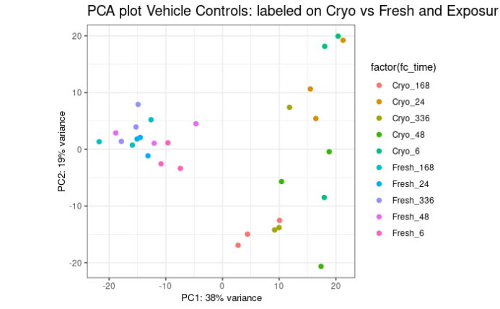

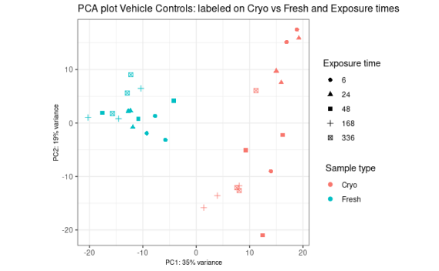



168 hours hours

48 hours hours

24 hours hours

6 hours

6 hours

### Secondary Exploratory analysis:

Heatmap **(Figure 1)** illustrates the gene expression patterns of the LPS and TGF-β pathways in precision-cut lung slices (PCLS) treated with LPS and TGF-β across various time points, doses, and preservation methods. The columns are organized by time point, with the first group representing 6 hours, followed by 24 hours, 48 hours, and 168 hours. The color gradient represents the level of gene expression, ranging from low (blue) to high (red).

For the TGF-β pathway, the data indicate a significant increase in gene expression starting at the 24-hour time point, persisting through 48 and 168 hours. Notably, gene expression is generally higher in cryopreserved samples compared to those processed fresh, suggesting that cryopreservation may enhance pro-fibrotic responses. A dose-dependent effect was observed, with increased expression noted at doses exceeding 5 ng, although no significant differences were detected at higher doses.

The LPS pathway data show distinct gene expression patterns at 6, 24, and 48 hours, with no data available for the 168-hour time point. Unlike the TGF-β pathway, the LPS-related gene expression was higher in fresh samples compared to cryopreserved ones at the 24-hour mark. By 48 hours, the effect appeared to diminish.

The temporal dynamics of gene expression in response to TGF-β and LPS treatments provide crucial insights into the kinetics of pathway activation. The early response at 6 hours and the sustained increase in expression at 24, 48, and 168 hours for the TGF-β pathway suggest a prolonged activation. This contrasts with the LPS pathway, where the distinct gene expression changes at 24 hours but not at 168 hours indicate a more transient response to LPS stimulation.

**Overall, the heatmap reveals a consistent activation of TGF-β-related pathways with cryopreservation, regardless of treatment. This finding suggests that cryopreservation may inherently induce a pro-fibrotic response, as evidenced by the increased expression of these pathways in the vehicle and LPS-treated samples across all time points.**

a

**Figure 2: Clustering and Pathway Analysis of TGF-β and LPS Pathways in PCLS**

The PCA and clustering analysis reveal distinct gene expression profiles associated with different treatments and conditions:

**- Cluster 0:** The cluster includes both cryopreserved and fresh samples from later time points, predominantly under TGF-β treatment. It is characterized by the enrichment of pathways related to TGF-β, Rho GTPases, PDGF signaling, and extracellular matrix (ECM) remodeling. These pathways suggest a strong involvement in cell signaling, cytoskeletal dynamics, and tissue restructuring processes.

**- Cluster 1:** Comprising samples from cryopreserved tissues, this cluster includes control, LPS, and TGF-β treatments, mainly from early time points (24 and 48 hours). The gene expression profiles in this cluster are enriched for pathways involved in leukocyte recruitment and activation, cytokine signaling, and Th1 immune responses. This indicates a heightened immune response, potentially driven by the preservation method and early treatment effects.

**- Cluster 2:** This cluster primarily consists of samples treated with LPS, predominantly using fresh (non-cryopreserved) tissue processing. This cluster is enriched in pathways related to interferon-gamma signaling, LPS response, and chemotaxis. The presence of interferon-gamma and chemotactic signaling pathways suggests a role in immune regulation and cell migration processes, likely reflecting a shift towards adaptive immune responses or acute inflammation.



**Temporal Dynamics and Gene Expression Clustering in PCLS for TGF-β Stimulation**

This figure presents the results of an RNA-seq analysis on precision-cut lung slices (PCLS) treated with TGF-β , focusing on differential gene expression across various time points, concentrations, and preservation methods (Cryo vs. Fresh). The analysis includes a heatmap of clustered gene expression, enrichment plots, and line graphs depicting expression trends.

* The heatmap displays gene expression levels across different samples, categorized into three clusters identified through temporal dynamic clustering using the TMixClust method. The samples are organized by time points (24, 48, 148, 336 hours) and treatment conditions (TGF-β, Vehicle Control). The color gradient ranges from blue (low expression) to red (high expression).
  + **Cluster 2:** Features genes with an increasing upregulation over time, indicating an ascending trend. This cluster is enriched with transcription factors (TFs) such as **CREB1, TP63, TP53, E2F1, NELFE, CHD1, and PPARD**. These TFs suggest involvement in cell cycle differentiation, transcriptional regulation, and metabolic signaling. Signicantly overexpressed genes in TGF-B vs CTRL in these cluster are POSTN, CTCHR1, and GDF15, PRELP, PLK2, SPARC and THSB1.
  + **Cluster 1:** Contains genes with stable expression across all time points, implying consistent activation or repression. The enriched TFs in this cluster include **MYOD1, REST, and FOXM1**, which are associated with regulatory processes that maintain steady state conditions or consistent gene expression levels.
  + **Cluster 3:** Comprises genes that show a decreasing trend in expression over time. The expression levels are higher at earlier time points and gradually decrease, indicating early response genes that diminish over time. The TFs enriched in this cluster are **FLI1, FOSL2, and MYC**, highlighting their roles in initial response phases and early signaling events. Genes DE in TGF-B vs CTRL in this cluster are: KRT7, KRT8, TIMP1, SLAMF8, SLAMF9, SLPI, SFTPC.